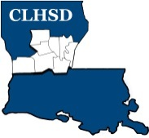
Central Louisiana Human Services District
Annual Board Meeting Agenda
July 2, 2019 @ 5:30 p.m.

- Call to Order/Quorum
- Prayer/Pledge

- Read and Approve the Annual Meeting Agenda (Vote)
Solicit Public Comment Requests

- ANNUAL MEETING
- Present Slate of Officers

- Vote for Officers (Ballot)

- Seat new officers – New officers to the head of the table

- Adjourn annual meeting

